BIT 4107 – Mobile Application Development
ENHANCED PROFESSIONAL STUDENT LOGBOOK
Student Name: _FAITH NJERI NDEGWA_____________________________
Admission Number: _ ____________ BIT/2024/54252_________________
School/Faculty: ________MKU______________________
Programme: _____ Mobile Application Development ____________________
Academic Year: ________3rd YEAR_____________________
Semester: __________2___________________
Lecturer: ___________MICHAEL NYORO___________________
Phone Number: ________0790661387______________________

Instructions
This logbook is used to document weekly learning activities, practical exercises, skills acquired, challenges encountered, solutions applied, and reflections. Students should complete all sections every week.
Each week to follow remarks in week 1 section.

Autogenerated Table of content

Week 1: Introduction to Mobile Application Development

Practical Activities Undertaken
Installation process
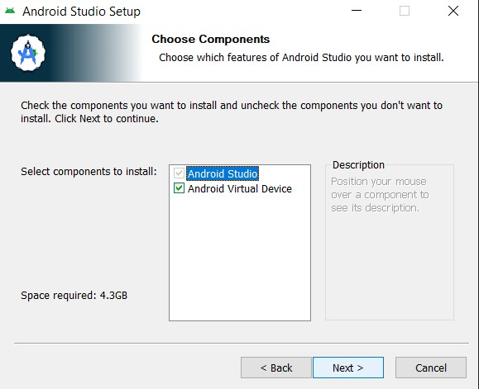

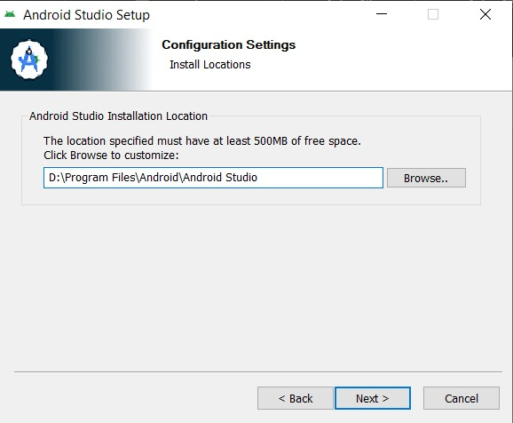
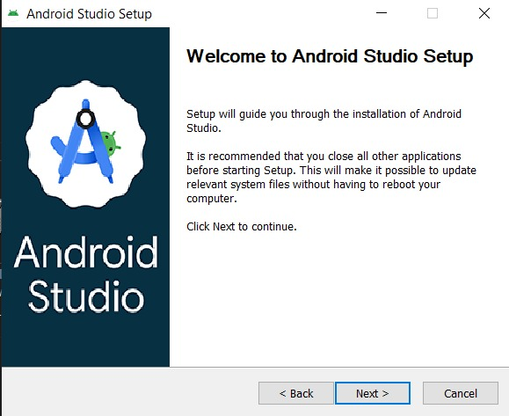

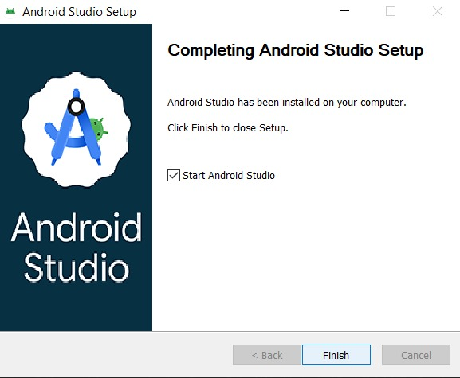

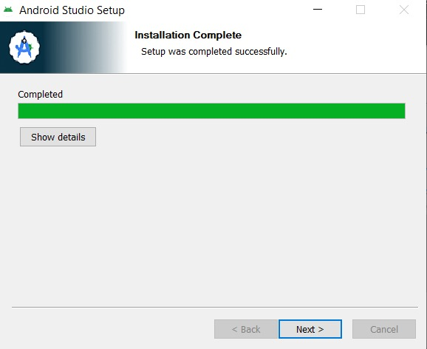

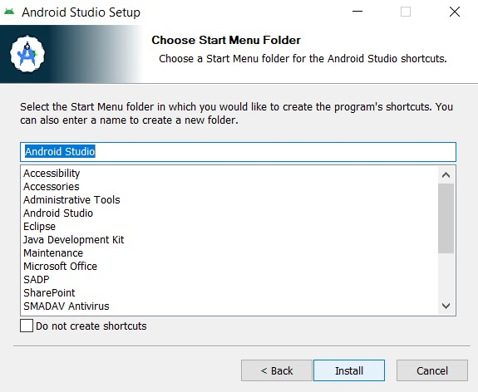

Tools/Software Used
Tool Used : Android Studio (with Kotlin/Jetpack Compose)

Personal Reflection
Reflection (Less than 50 words):
Through developing the SchoolLink app, a student should learn mobile application development, user interface design, navigation between screens, debugging, and testing on a real device. The project also builds problem-solving skills and demonstrates how technology can improve communication between schools and parents.

Week 2: Mobile Development Environment
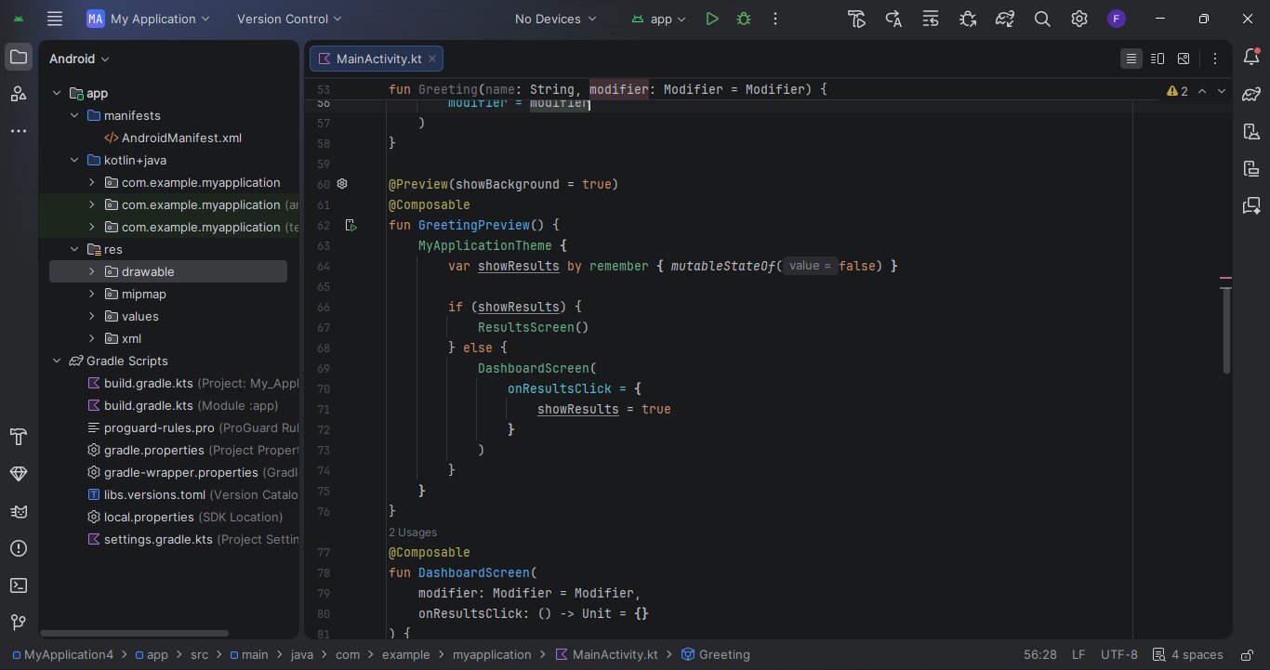
- Opening and setting up android studio
- Deciding and designing what i want to make

Week 3: User Interface Design
A screenshot of creating a user interface and linking then tasks together
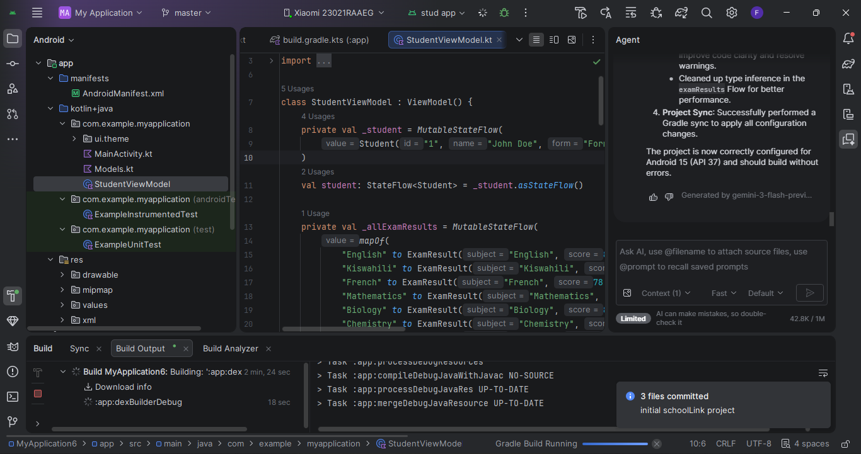
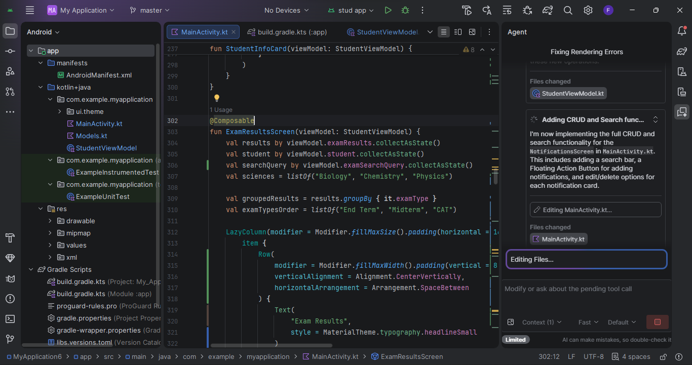
Tools used: Android studio, Java, Kotlin

Week 4: Event Handling and User Interaction
LINKING MY PHONE AND ENABLING ACTIVITIES TO RUN ON THE PHONE
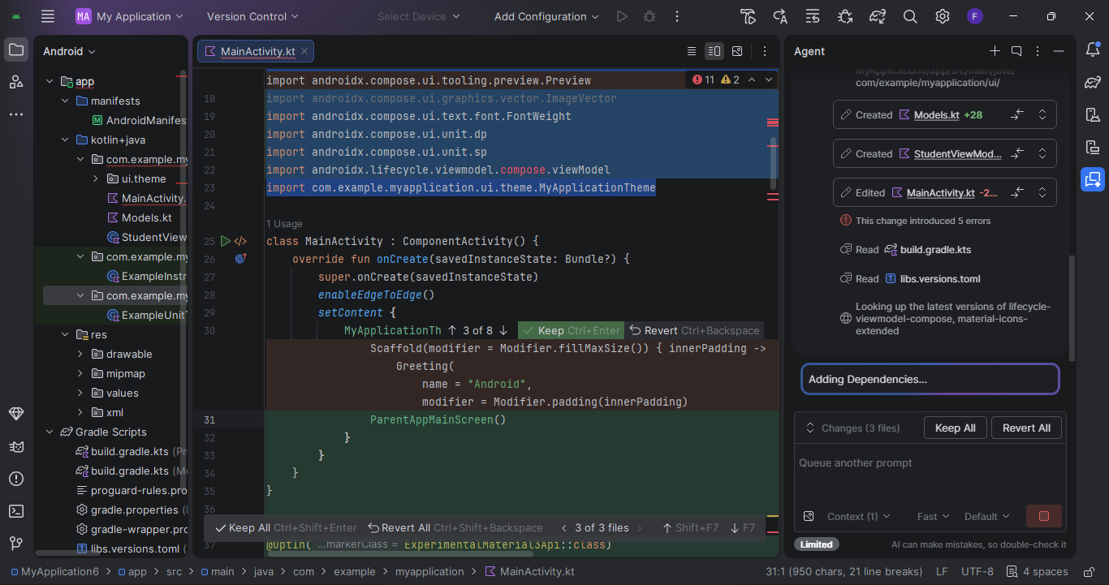

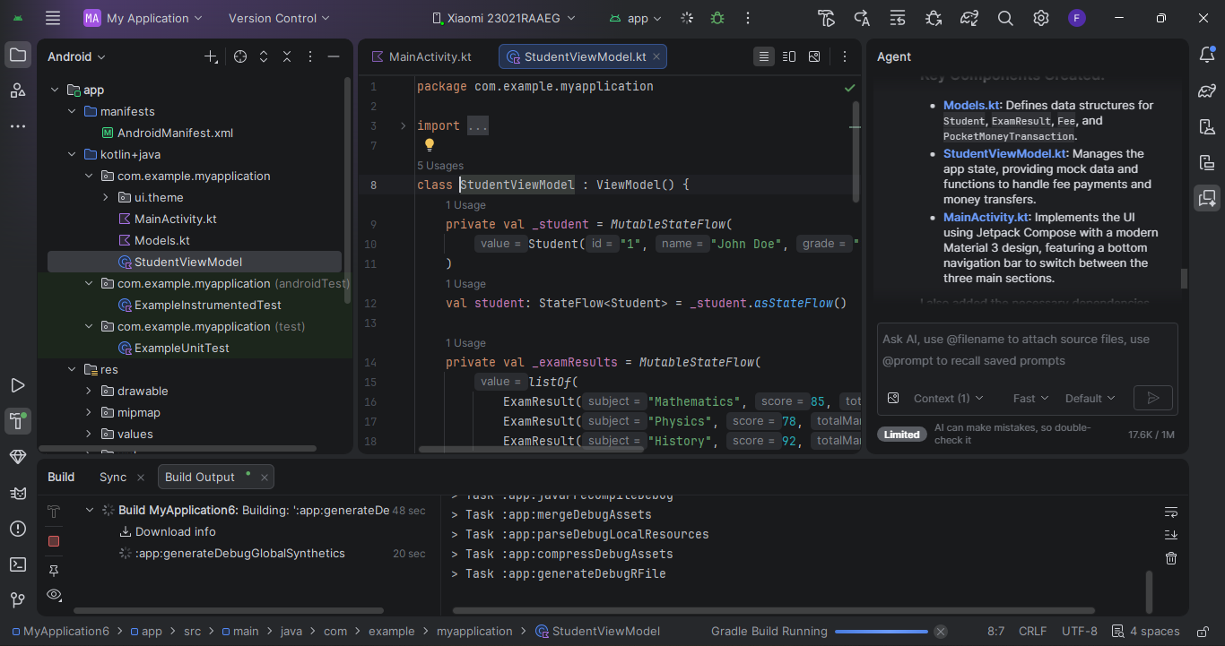

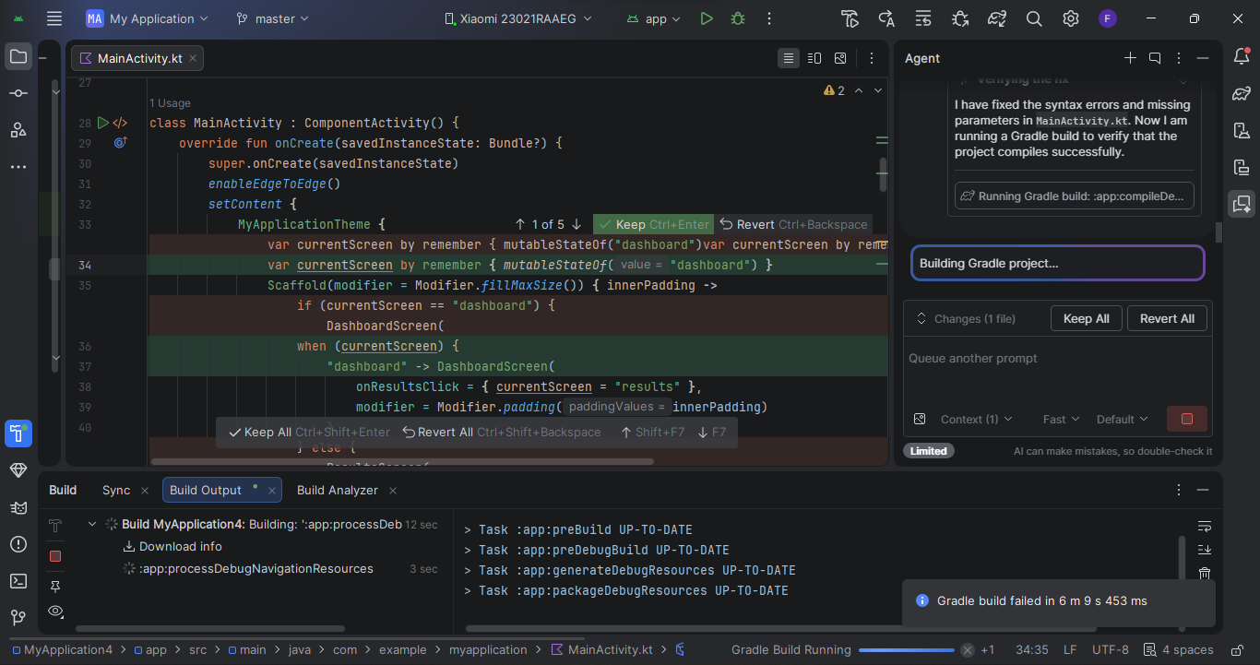

Week 5: Data Management
Activities Undertaken
During this week, I focused on data management aspects of the SchoolLink mobile application. I designed how student, parent, examination, attendance, and fee information would be stored and managed within the system. I also created data structures for handling user information and academic records.
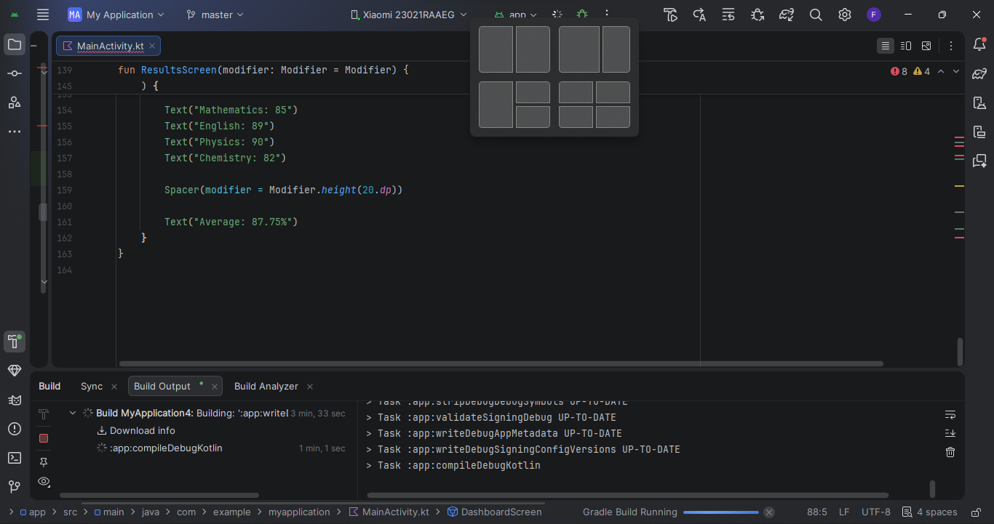
Managing data in my school app like the results
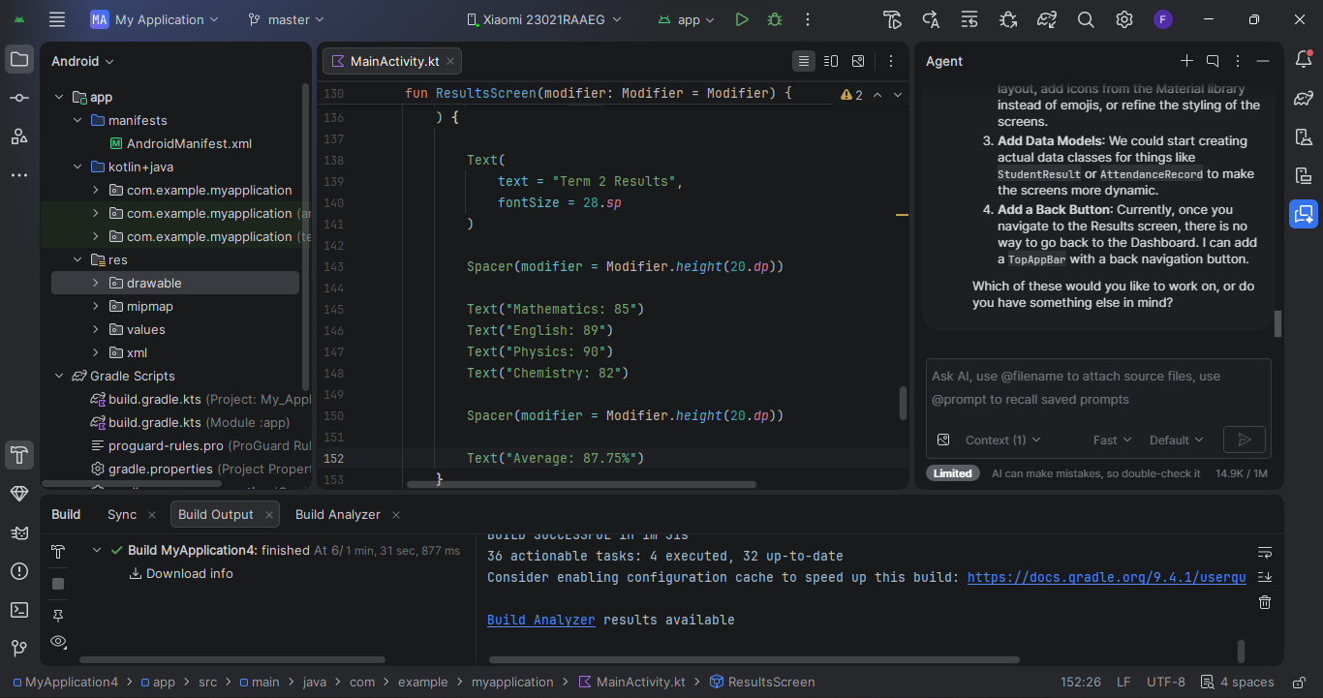
Tool Used
Android Studio
Kotlin Programming Language
Jetpack Compose
Firebase Real-time Database (planned database solution)
Documentation
Data management is an important component of the SchoolLink application because it enables the storage, retrieval, and updating of information. The application is designed to manage student records, examination results, attendance reports, fee balances, and pocket money transactions. Data is organized into different categories to ensure efficient access and security. Proper data management helps maintain data accuracy, consistency, and reliability within the system.
Skills Learned
Data organization and structuring
Database planning and design
Managing application data using Kotlin
Understanding data storage concepts in mobile applications
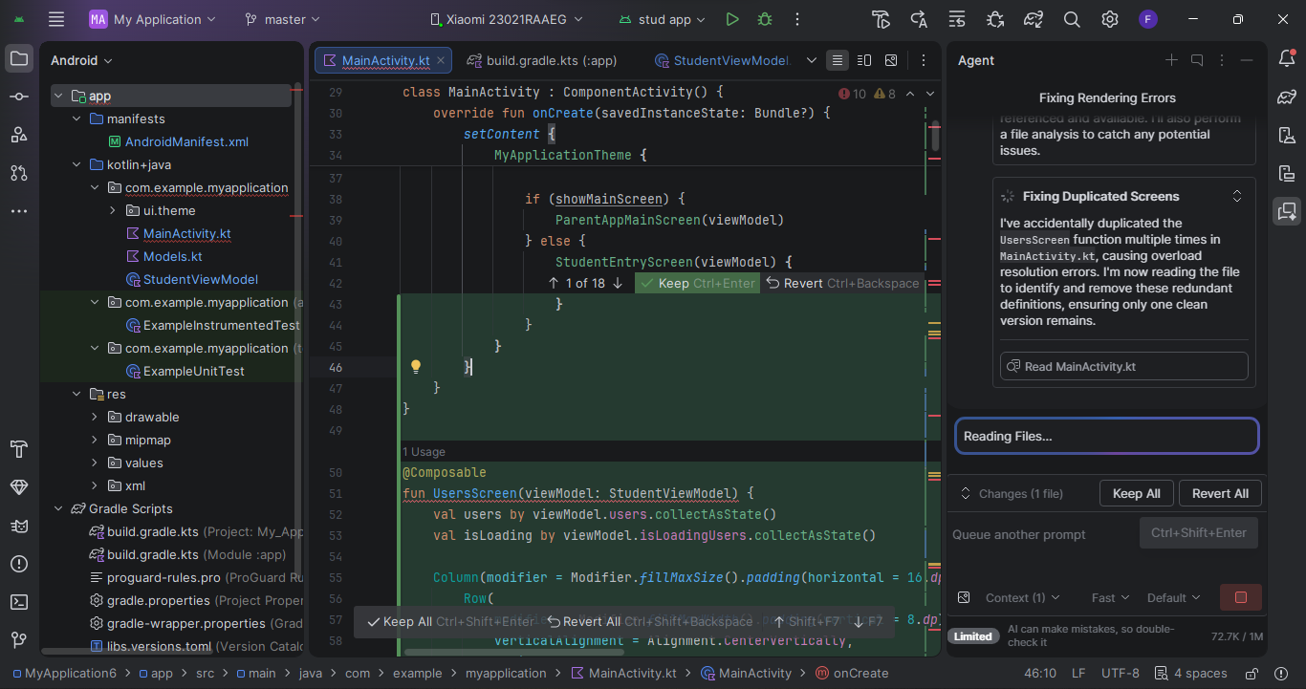

Week 6: Networking and APIs
Activities Undertaken
During this week, I studied networking concepts in mobile application development. I implemented a network configuration file and explored how the application would communicate with an online database to retrieve and update information such as examination results, attendance records, fee payments, and pocket money transactions.
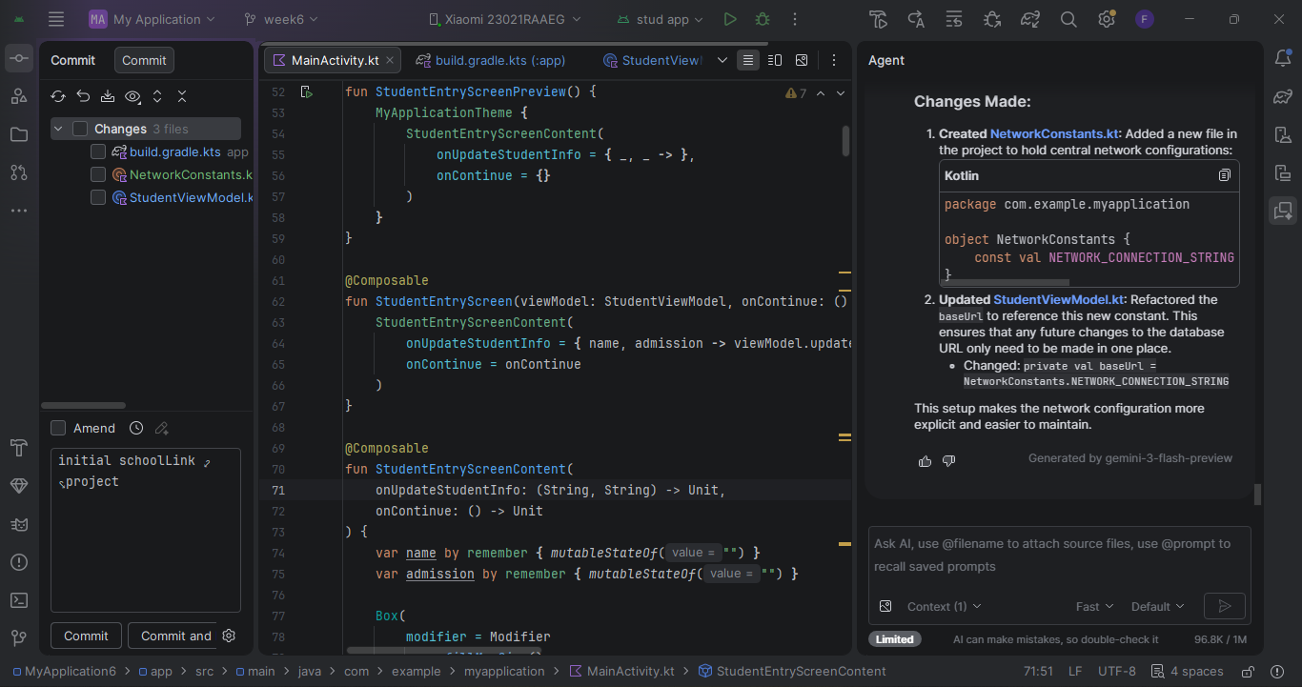
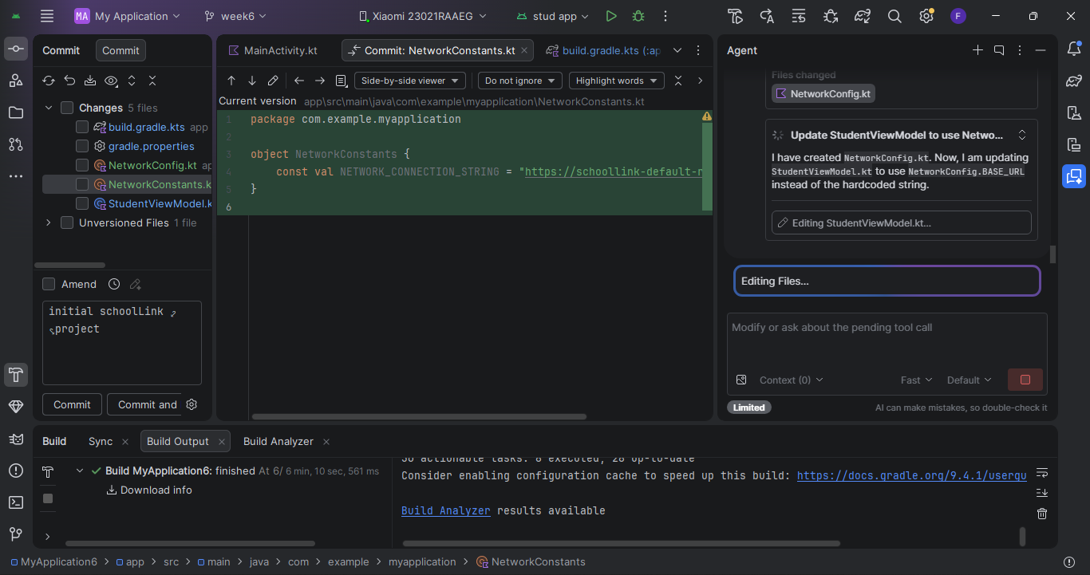
Code showing it's android studio with network connection string
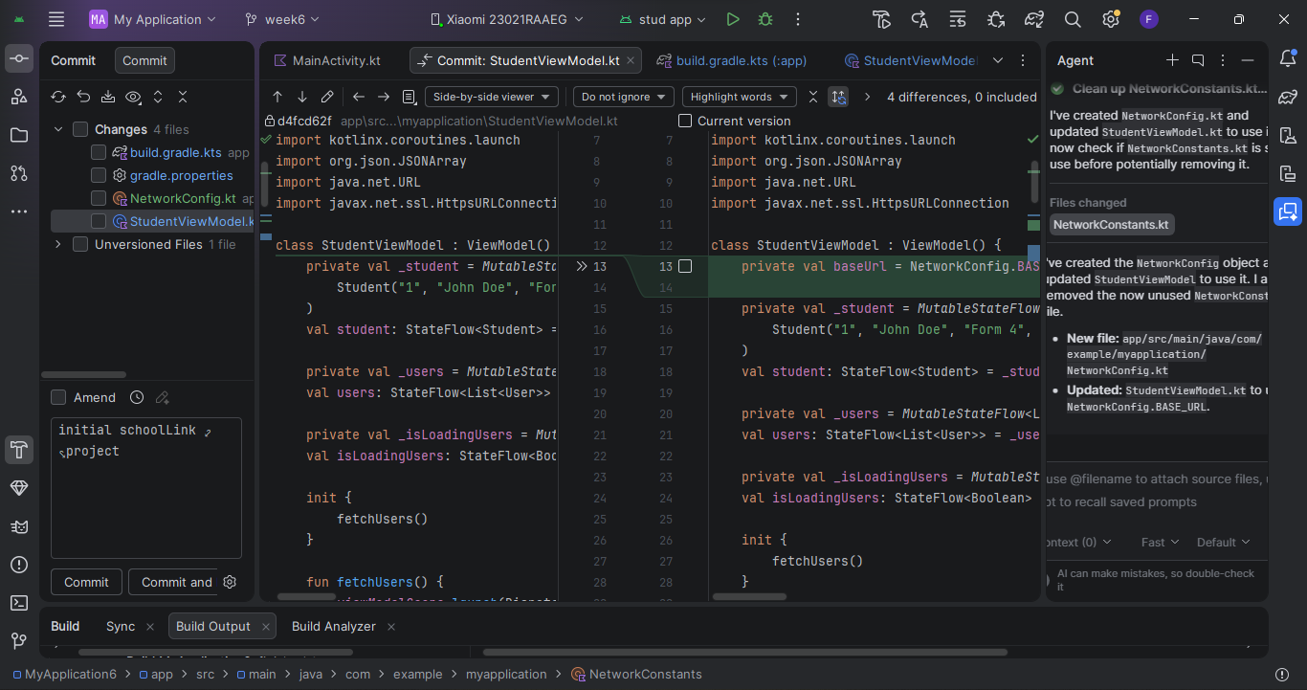
Screenshot of the code with connection string.
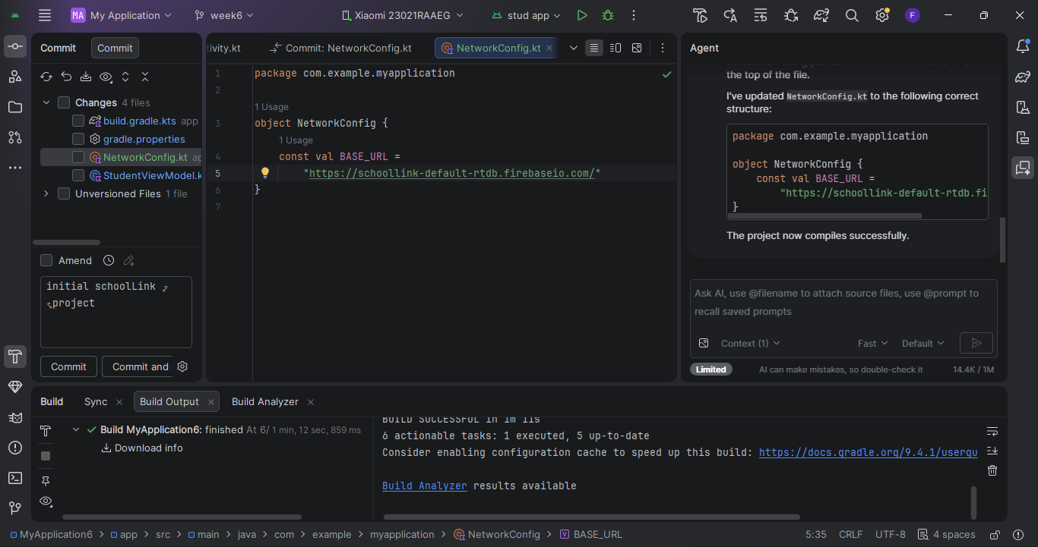

Tool Used
Android Studio
Kotlin Programming Language
Internet Connectivity
Firebase Realtime Database (planned)
Why the App Requires Networking (Less than 20 Words)
SchoolLink requires networking to retrieve results, process payments, send pocket money, and receive school updates.
Skills Learned
Mobile networking concepts
Client-server communication
API and database connectivity
Network configuration in Android applications
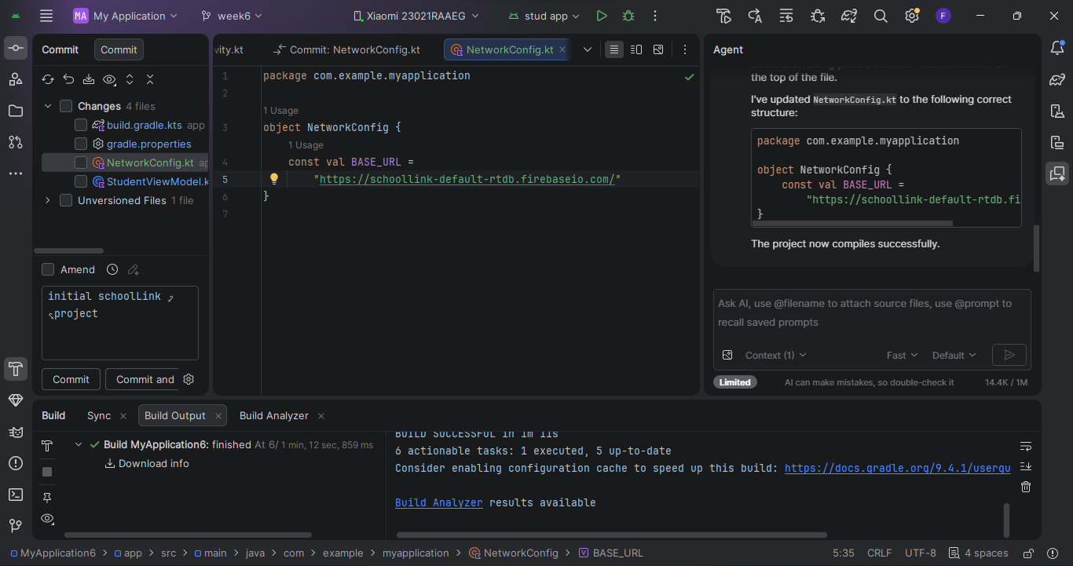

Week 7: Application Architecture

Same as week 1

Week 8: Project Planning

Week 9: Device Features and Sensors

Same as week 1

Week 10: Notifications and Background Services

Same as week 1

Week 11: Mobile Security

Same as week 1

Week 12: Testing and Debugging

Same as week 1

Week 13: Application Deployment

Same as week 1

Week 14: Final Project Presentation

Same as week 1

Semester Project Tracking

Project Title

Project Objectives

Project Requirements

Development Milestones

Testing Results

Lessons Learned

Future Improvements

End of Semester Reflection

Summary of Skills Acquired

Most Interesting Topic

Major Challenges Faced

How Challenges Were Overcome

Professional Growth Achieved

Overall Course Experience

Final Approval
Student Name: __________________________
Student Signature: ______________________
Date: _________________________________
Lecturer Name: _________________________
Lecturer Remarks: _____________________
Date: _________________________________

